**Identification of the following hardware components that are needed in embedded system design:**

UART (Universal Asynchronous Receiver-Transmitter):

* A simple two-wire serial communication protocol (TX and RX)
* Asynchronous (no clock signal) - both sides must agree on speed (baud rate)
* Good for point-to-point communication up to moderate speeds
* Common in debugging, bootloaders, and basic device-to-device communication
* Typical speeds: 9600 to 115200 baud
* Pros: Simple, widely supported
* Cons: Limited to two devices, moderate speed

SPI (Serial Peripheral Interface):

* Synchronous serial protocol with clock signal
* Uses 4 wires: MOSI (Master Out Slave In), MISO (Master In Slave Out), SCK (Clock), CS (Chip Select)
* One master can control multiple slaves using separate CS lines
* Very high speed possible (several MHz)
* Common in sensors, memory chips, displays
* Pros: Fast, full-duplex communication
* Cons: Requires more pins, not good for long distances

I²C (Inter-Integrated Circuit):

* Two-wire serial protocol (SDA for data, SCL for clock)
* Multiple masters and slaves can share the same bus
* Each device has a unique address
* Medium speed (100kHz standard, up to 5MHz in high-speed mode)
* Common in sensor networks, EEPROMs, display drivers
* Pros: Fewer pins, multi-device support
* Cons: More complex than SPI, slower

Wi-Fi:

* Wireless networking based on IEEE 802.11 standards
* High bandwidth (up to several Gbps in newer standards)
* Long range (up to 100m indoors)
* Supports complex networking with many devices
* Common in IoT devices, home automation
* Pros: High speed, widespread support, good range
* Cons: Higher power consumption, more complex to implement

Bluetooth:

* Short-range wireless protocol
* Various versions (Classic, Low Energy/BLE)
* BLE optimized for low power consumption
* Range typically 10-100m depending on version and power
* Common in mobile devices, wearables, IoT
* Pros: Low power (BLE), good standardization
* Cons: Limited range, moderate bandwidth

RF (Radio Frequency):

* Generic term for wireless communication using radio waves
* Many protocols and frequencies available
* Common frequencies: 433MHz, 868MHz, 915MHz, 2.4GHz
* Can be very simple (basic modulation) or complex (digital protocols)
* Used in remote controls, sensors, IoT
* Pros: Very flexible, can be simple or sophisticated
* Cons: May require regulatory compliance, potential interference

Selection Considerations:

1. Distance requirements
2. Power consumption needs
3. Data rate requirements
4. Number of devices to connect
5. Cost and complexity constraints
6. Environmental factors (interference, obstacles)
7. Regulatory requirements

Would you like me to elaborate on any particular interface or aspect?

**Summary of the Protocol in Table**

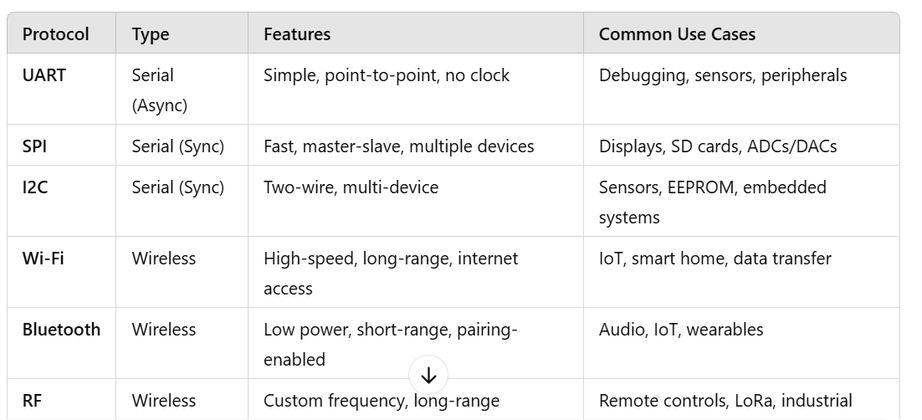

Each protocol is designed for specific applications, and the choice depends on factors like speed, distance, power, and complexity.